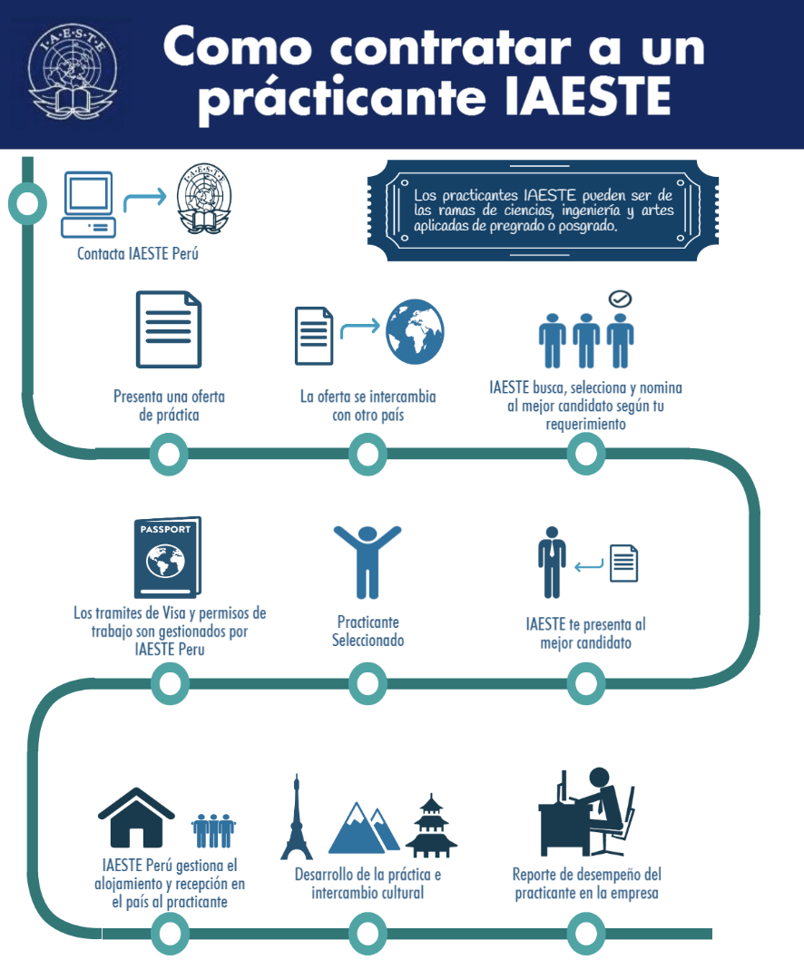

INTERNATIONAL ASSOCIATION FOR EXCHANGE OF STUDENTS FOR TECHNICAL EXPERIENCE

IAESTE PERU
Calle Mártir Olaya 162, Miraflores
Tel: +51 1 2139600 ext.2223
E-mail: peru.iaeste@udep.pe; Sheyla.salazar@udep.pe

OFERTA DE PLAZA

Información del empleador

Institución o empresa:_______________________________________________________

Dirección:

Teléfono: Página web: _______________________________

Persona responsable: Email Address:

Rubro del Institución o empresa:

Lugar de practicas (Referencia de ubicación):

Referencia de transporte hacia el lugar de practicas: __________________________________________________________________________________________________________________________________________________________

Número de empleados: Número de horas por semana:

Horario diario. Desde ____. ____am Hasta ____. ____pm

Estudiante requerido

Facultad:

Especialización: ………………………………………………………………………………………………………………………..

Nivel de estudios 1ros años (1-4 Semesters)

Mitad de carrera (5-6 Semesters)

Ultimos años (7 Semesters and Over)

Maestría

¿Requiere que tenga experiencias y/o practicas previas? SI NO
Idioma (s) requeridos:
Número de estudiantes y/o plazas requeridas:

Propuesta de prácticas

Tipo de prácticas (Sea lo mas detallado posible, sobre la descripción de las tareas que desempeñará alumno y sobre lo que se espera de su período de practicas). Anexar pagina si lo considera
____________________________________________________________________________
______

Categorías: Investigación y Desarrollo (D)
Profesional (trabajo en Oficina)(P)
Trabajo de campo (W)
No-especifica (X)

Número de semanas ofrecidas: minimo máximo

Entre las fechas de DD MM YY a DD MM YY

Pago total por (mes/semana/hora):

El pago será : semanal mensual otra

¿Se require alguna vestimenta especial? NO SI

Accommodation
¿Puede el empleador coordinar el alojamiento? NO
/ SI
La renta mensual es (en caso de rpta. anterior se afirmativa):
¿Hay comedor disponible en el trabajo? NO
SI

Compromiso del empleador
Confirmo la oferta propuesta para un estudiante internacional. Estaremos a la espera de recibir propuesta.

Firma Fecha

